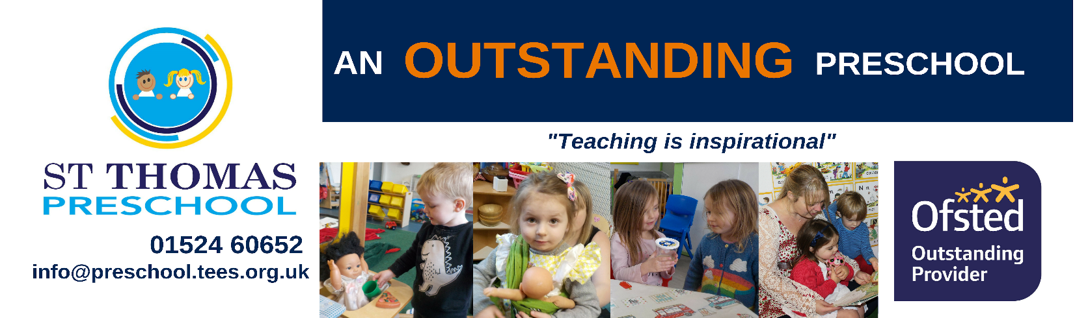
Welcome to St Thomas Pre-School! We are a small, nurturing pre-school in which 2 to 4 year-olds play and learn together. In February 2019 we were inspected by OFSTED and judged to be outstanding – a copy of the report is included in this information pack. The Pre-School operates as an extension of St Thomas’ Church but is open to all members of the community. St Thomas Pre-School has a distinct Christian ethos, but it is not just for Christian families. We welcome and value families of all faiths and none at pre-school.

Pre-School runs in school term time only, 38 weeks per year.

From September 2020 our opening hours will be:
Monday 9:00am-3:00pm
Tuesday 9:00am-3:00pm
Wednesday 9:00am-3:00pm
Thursday 9:00am-3:00pm

We offer 15 free hours to all 3 and 4 year olds and to eligible 2 year olds. You can claim your 15 hours over 5 mornings (9:00am-12:00pm) or two and a half days. Lunch club is an extra £2.50, and can be added on to a morning sessions and paid for, and if you are eligible for the 30 hours of free childcare you can claim up to 24 hours at pre-school, which is the total number of hours we are currently open each week. Extra hours can be saved up and used at one of the holiday playschemes in Lancaster.
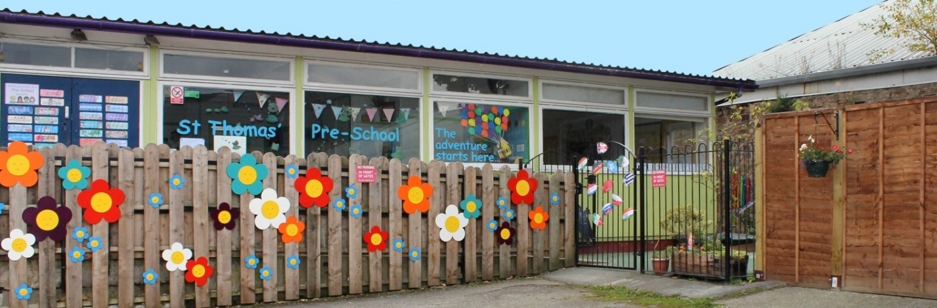
We accept all nursery vouchers, and you can pay for additional sessions if you wish.
“A home away from home.”
This prospectus aims to provide you with an introduction to St Thomas’ Preschool, our routines, our approach to supporting your child’s learning and development and how we aim to work together with you to best meet your child’s individual needs. This should be read alongside our Childcare Terms and Conditions for a full description of our services.
Our setting aims to:
- provide high quality care and education for children below statutory school age;
- work in partnership with parents to help children to learn and develop;
- add to the life and well-being of the local community; and
- offer children and their parents a service that promotes equality and values diversity.

Parents
You are regarded as members of our setting who have a right to be:
- valued and respected;
- kept informed;
- consulted; and
- involved.

Children's development and learning
We aim to ensure that each child:
- is in a safe and stimulating environment;
- is given generous care and attention, because of our ratio of qualified staff to children;
- has the chance to join in with other children and adults to live, play, work and learn together;
- is helped to take forward her/his learning and development by being helped to build on what she/he already knows and can do;
- has a personal key person who makes sure each child makes satisfying progress;
- is in a setting that sees parents as partners in helping each child to learn and develop; and
- is in a setting in which parents help to shape the service it offers.

The Early Years Foundation Stage
Provision for the development and learning of children from birth to 5 years is guided by the Early Years Foundation Stage. Our provision reflects the four overarching principles of the Statutory Framework for the Early Years Foundation Stage (DfE 2014):

- A Unique Child
Every child is a unique child who is constantly learning and can be resilient, capable, confident and self-assured.
- Positive Relationships
Children learn to be strong and independent through positive relationships.
- Enabling Environments
Children learn and develop well in enabling environments, in which their experiences respond to their individual needs and there is a strong partnership between practitioners, parents and carers.
- Learning and Development
Children develop and learn in different ways and at different rates. The framework covers the education and care of all children in early years provision including children with special educational needs and disabilities.

How we provide for development and learning
Children start to learn about the world around them from the moment they are born. The care and education offered by our setting helps children to continue to do this by providing all of the children with interesting activities that are appropriate for their age and stage of development.

The Areas of Development and Learning comprise:
- Prime Areas
- Personal, social and emotional development.
- Physical development.
- Communication and language.
- Specific Areas
- Literacy.
- Mathematics.
- Understanding the world.
- Expressive arts and design.

For each area, the level of progress that children are expected to have attained by the end of the Early Years Foundation Stage is defined by the Early Learning Goals. These goals state what it is expected that children will know, and be able to do, by the end of the reception year of their education.
The Early Years Outcomes (DfE 2013) guidance sets out the likely stages of progress a child makes along their progress towards the Early Learning Goals. Our setting has regard to these when we assess children and plan for their learning. Our programme supports children to develop the knowledge, skills and understanding they need for:
Personal, social and emotional development
- making relationships;
- self-confidence and self-awareness; and
- managing feelings and behaviour.

Physical development
- moving and handling; and
- health and self-care.

Communication and language
- listening and attention;
- understanding; and
- speaking.

Literacy
- reading; and
- writing.
Mathematics
- numbers; and
- shape, space and measure.

Understanding the world
- people and communities;
- the world; and
- technology.

Expressive arts and design
- exploring and using media and materials; and
- being imaginative.

Our approach to learning and development and assessment
Learning through play
Being active and playing supports young children’s learning and development through doing and talking. This is how children learn to think about and understand the world around them. We provide opportunities which will help children to make progress in all areas of learning. This programme is made up of a mixture of activities that children plan and organise for themselves and activities planned and led by practitioners. The majority of the planning at preschool is done ‘in the moment’ as we find this is the best way to truly follow children’s interests and engage them in the highest level of learning.
We make periodic assessment summaries of children’s achievement based on our on-going development records and our knowledge of your child. These form part of children’s records of achievement. We undertake these assessment summaries at regular intervals, as well as times of transition, such as when a child moves into a different group or when they go on to school.

The progress check at age two

The Early Years Foundation Stage requires that we supply parents and carers with a short written summary of their child’s development in the three prime areas of learning and development - personal, social and emotional development; physical development; and communication and language - when a child is aged between 24 - 36 months. Your child’s key person is responsible for completing the check using information from on-going observational assessments carried out as part of our everyday practice, taking account of the views and contributions of parents and other professionals.

Records of achievement

We keep a record of achievement for each child. Your child's record of achievement helps us to celebrate together her/his achievements and to work together to provide what your child needs for her/his well-being and to make progress.

Your child's key person will work in partnership with you to keep this record. To do this we use an online ‘learning journey’ called Tapestry. You can download the Tapestry app to your phone or tablet and receive regular updates about your child’s learning in preschool.
Key person and your child
Our setting uses a key person approach. This means that each member of staff has a group of children for whom she/he is particularly responsible. Your child's key person will be the person who works with you to make sure that the childcare that we provide is right for your child's particular needs and interests. When your child first starts at the setting, she/he will help your child to settle and throughout your child's time at the setting, she/he will help your child to benefit from our activities.

The setting's timetable and routines
Our setting believes that care and education are equally important in the experience which we offer children. The routines and activities that make up the day in our setting are provided in ways that:
- help each child to feel that she/he is a valued member of the setting;
- ensure the safety of each child;
- help children to gain from the social experience of being part of a group; and
- provide children with opportunities to learn and help them to value learning.

The session
We organise our sessions so that the children can choose from a range of activities. As a small setting we are able to be very flexible, and this, along with our ‘in the moment’ approach to planning means that we are constantly assessing and adjusting our provision to meet the need of your child. Children are encouraged to spend time both indoors and outdoors in each session, and we have a short ‘circle time’ in each session where we share stories and songs and provide some teacher input on a variety of topics.
Snacks and meals
We ask that you send a packed lunch with your child, and piece of fruit for morning snack. We provide milk to drink, and ask that you send a named bottle of water or whatever your child normally drinks throughout the day.
Clothing
We encourage children to gain the skills that help them to be independent and look after themselves. These include taking themselves to the toilet and taking off and putting on outdoor clothes. Clothing that is easy for them to manage will help them to do this. In order to feel free to explore and experiment with all kinds of materials, including messy ones, it is best to send children dressed in clothes which are easily washable or not too new. Bringing a spare set of clothes each day is useful, however we do have a range of spare clothes if needed.
Policies
Our staff can explain our policies and procedures to you. Copies of which are available in preschool. Our policies help us to make sure that the service provided by our setting is a high quality one and that being a member of the setting is an enjoyable and beneficial experience for each child and her/his parents. Our polices are reviewed regularly, this helps us to make sure that the policies are enabling our setting to provide a quality service for its members and the local community.
Information we hold about you and your child
We have procedures in place for the recording and sharing of information [data] about you and your child that is compliant with the principles of the General Data Protection Regulations (2018) as follows:
The data is we collect is
- Processed fairly, lawfully and in a transparent manner in relation to the data subject [you and your family]
- Collected for specified, explicit and legitimate purposes and not further processed for other purposes incompatible with those purposes.
- Adequate, relevant and limited to what is necessary in relation to the purposes for which data is processed.
- Accurate and, where necessary, kept up to date.
- Kept in a form that permits identification of data subjects [you and your family] for no longer than is necessary for the purposes for which the personal data is processed.
- Processed in a way that ensures appropriate security of the personal data including protection against unauthorised or unlawful processing and against accidental loss, destruction or damage, using appropriate technical or organisational measures.
When you register your child with us we will provide you with a privacy notice that gives you further details of how we fulfil our obligations with regard to your data.
Safeguarding children
Our setting has a duty under the law to help safeguard children against suspected or actual ‘significant harm’. Our employment practices ensure children against the likelihood of abuse in our setting and we have a procedure for managing complaints or allegations against a member of staff.
Our way of working with children and their parents ensures that we are/ aware of any problems that may emerge and can offer support, including referral to appropriate agencies when necessary, to help families in difficulty.
Special needs
To make sure that our provision meets the needs of each individual child, we take account of any special needs a child may have. We work to the requirements of the Special Educational Needs and Disability Code of Practice: 0 to 25 years (2015).
Our Special Educational Needs Co-ordinators are | Jessica Fitton and Claire Colclough

The management of our setting
Our setting is a charity and is managed by a voluntary management committee made up of parents and church representatives. The preschool operates as an extension of the mission and ministry of St Thomas’ Church. The committee make up the registered person with Ofsted and are responsible for:
- managing our finances;
- employing and managing our staff;
- making sure that we have, and work to, policies that help us to provide a high quality service; and
- making sure that we work in partnership with parents.

Fees
Fees for 2020/2021 are as follows:
 | Morning session  9:00am-12:00pm | Lunch  12:00pm-12:30pm | Afternoon session  12:30pm-3:00pm | FlexiCare session
2 year olds | £13.80 | £2.50 | £11.50 | £5 per hour
3+ year olds | £12.60 | £2.50 | £10.50
Please note fees are reviewed annually and maybe subject to increase.
Fees are payable half termly in advance. (Separate terms and conditions apply for the FlexiCare sessions). An invoice will be sent to you at the beginning of each half term via email. If you would prefer to receive a paper invoice please let us know. Fees must still be paid if children are absent without notice for a short period of time. If your child has to be absent over a long period of time, talk to Claire Colclough who is the committee chair or Jessica Fitton who is our manager.
For your child to keep her/his place at our setting, you must pay the fees. We are in receipt of nursery education funding for two, three and four year olds; where funding is not received, then fees apply.
Starting at our setting
The first days
We want your child to feel happy and safe with us. To make sure that this is the case, our staff will work with you to decide on how to help your child to settle into the setting. We allow 1 free settling session per child (with a parent staying in the building) and this is usually enough for a child to get to know our setting and staff. It is not unusual for a child to cry when they are left for the first few times, but with support from their key person they are usually able to settle after a few minutes and enjoy the session. If a child does not settle, or becomes very distressed during a session we will call you and ask you to collect them if possible.
We hope that you and your child enjoy being members of our setting and that you both find taking part in our activities interesting and stimulating. Our staff are always ready and willing to talk with you about your ideas, views or questions.

